

St Andrew's Church

Orford with Longford

**The Third Sunday of Advent**

**16th December 2018**

**THE GATHERING**

**Introit hymn:** *(please stand)* 34 ‘On Jordan’s bank, the Baptist’s cry

Priest: In the name of the Father and of the Son and of the Holy Spirit. **Amen**

Priest: The Lord be with you

All: And also with you

All: Almighty God, to whom all hearts are open, all desires known, and from whom no secrets are hidden: cleanse the thoughts of our hearts by the inspiration of your Holy Spirit, that we may perfectly love you, and worthily magnify your holy name; through Christ our Lord. Amen.

**Lighting the Advent Wreath – John the Baptist**:

(please remain standing)

Priest: Jesus said, ‘No one more important than John the Baptist has ever been born; yet the least in the kingdom of heaven is greater than he.’

All: Amen. Come soon, Lord Jesus!

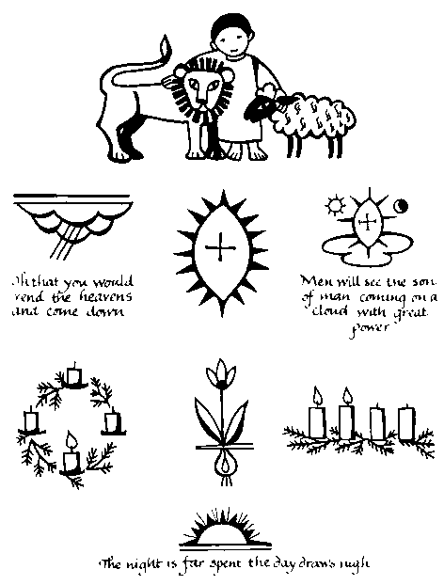The third candle is lit and this response is used

Priest: Jesus is the light of the world

All: A light no darkness can ever put out.

We sing (tune: Angel voices)

Advent candles tell their story

as we watch and pray,

longing for the Day of Glory

‘Come, Lord, soon,’ we say.

Pain and sorrow,

tears and sadness,

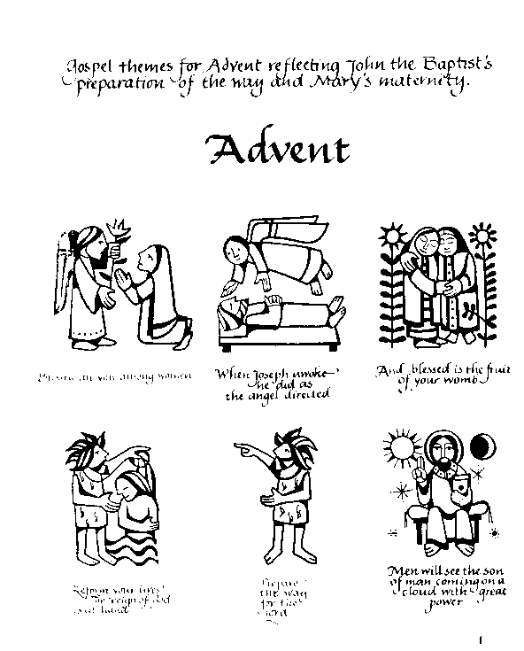changed for gladness on that Day.

John the Baptist, by his preaching

and by water poured,

brought to those who heard his teaching

news of hope restored:

‘Keep your vision

strong and steady,

and be ready for the Lord.’

**Prayers of Penitence**

Reader: When the Lord comes, he will bring to light the things now hidden in darkness, and will disclose the purposes of the heart. Therefore, in the light of Christ let us confess our sins

After a period for silent reflection:

All: Almighty God, our heavenly Father, we have sinned against you and against our neighbour in thought and word and deed, through negligence, through weakness, through our own deliberate fault. We are truly sorry and repent of all our sins. For the sake of your Son Jesus Christ, who died for us, forgive us all that is past, and grant that we may serve you in newness of life to the glory of your name. Amen.

All 🎜 Lord have mercy, Lord have mercy

Christ have mercy, Christ have mercy

Lord have mercy, Lord have mercy

Priest: Almighty God, who forgives all who truly repent, have mercy upon you, pardon and deliver you from all your sins, confirm and strengthen you in all goodness, and keep you in life eternal; through Jesus Christ our Lord. **Amen.**

Collect: O Lord Jesus Christ, who at your first coming sent your messenger to prepare the way for you: grant that the ministers and stewards of your mysteries may likewise so prepare and make ready your way by turning the hearts of the disobedient to the wisdom of the just, that at your second coming to judge the world we may be found an acceptable people in your sight; for you are alive and reign with the Father in the unity of the Holy Spirit, one God, now and for ever. Amen

The Liturgy of the Word

**A reading from the book of the prophet Zephaniah** *(Zeph 3. 14–20)*

Sing aloud, O daughter Zion; shout, O Israel! Rejoice and exult with all your heart, O daughter Jerusalem! The Lord has taken away the judgements against you, he has turned away your enemies. The king of Israel, the Lord, is in your midst; you shall fear disaster no more. On that day it shall be said to Jerusalem: Do not fear, O Zion; do not let your hands grow weak. The Lord, your God, is in your midst, a warrior who gives victory; he will rejoice over you with gladness, he will renew you in his love; he will exult over you with loud singing as on a day of festival. I will remove disaster from you, so that you will not bear reproach for it. I will deal with all your oppressors at that time. And I will save the lame and gather the outcast, and I will change their shame into praise and renown in all the earth. At that time, I will bring you home, at the time when I gather you; for I will make you renowned and praised among all the peoples of the earth, when I restore your fortunes before your eyes, says the Lord.

This is the word of the Lord.

All: Thanks be to God.

**Hymn:** *(remain seated)*  234 ‘Sing we the praises ...’

**A reading from the letter of Paul to the Philippians** *(Phil 4. 4–7)*

Rejoice in the Lord always; again I will say, Rejoice. Let your gentleness be known to everyone. The Lord is near. Do not worry about anything, but in everything by prayer and supplication with thanksgiving let your requests be made known to God. And the peace of God, which surpasses all understanding, will guard your hearts and your minds in Christ Jesus.

This is the word of the Lord.

All: Thanks be to God.

**Gradual hymn:** *(please stand)* 36 ‘The Advent of our King’

##### THE GOSPEL

Priest: Prepare the way of the Lord, make his paths straight;

and all flesh shall see the salvation of God.

**All 🎜 … Alleluia, alleluia, alleluia.**

Hear the gospel of our Lord Jesus Christ according to Luke *(Lk 3. 7–18)*

**All 🎜 Glory to you, O Lord**

John said to the crowds that came out to be baptized by him, ‘You brood of vipers! Who warned you to flee from the wrath to come? Bear fruits worthy of repentance. Do not begin to say to yourselves, “We have Abraham as our ancestor”; for I tell you, God is able from these stones to raise up children to Abraham. Even now the axe is lying at the root of the trees; every tree therefore that does not bear good fruit is cut down and thrown into the fire.’ And the crowds asked him, ‘What then should we do?’ In reply he said to them, ‘Whoever has two coats must share with anyone who has none; and whoever has food must do likewise.’ Even tax-collectors came to be baptized, and they asked him, ‘Teacher, what should we do?’ He said to them, ‘Collect no more than the amount prescribed for you.’ Soldiers also asked him, ‘And we, what should we do?’ He said to them, ‘Do not extort money from anyone by threats or false accusation, and be satisfied with your wages.’ As the people were filled with expectation, and all were questioning in their hearts concerning John, whether he might be the Messiah, John answered all of them by saying, ‘I baptize you with water; but one who is more powerful than I is coming; I am not worthy to untie the thong of his sandals. He will baptize you with the Holy Spirit and fire. His winnowing-fork is in his hand, to clear his threshing-floor and to gather the wheat into his granary; but the chaff he will burn with unquenchable fire.’ So, with many other exhortations, he proclaimed the good news to the people.

This is the gospel of the Lord.

All 🎜 Praise to you, O Christ

##### the sermon

Please stand to say the Nicene Creed:

Priest: We believe in one God,

**All: the Father, the almighty, maker of heaven and earth, of all that is, seen and unseen.**

We believe in one Lord, Jesus Christ, the only Son of God, eternally begotten of the Father, God from God, Light from Light, true God from true God, begotten, not made, of one Being with the Father; through him all things were made. For us and for our salvation he came down from heaven, was incarnate from the Holy Spirit and the Virgin Mary and was made man. For our sake he was crucified under Pontius Pilate; he suffered death and was buried.

On the third day he rose again in accordance with the Scriptures; he ascended into heaven and is seated at the right hand of the Father. He will come again in glory to judge the living and the dead, and his kingdom will have no end.

We believe in the Holy Spirit, the Lord, the giver of life, who proceeds from the Father and the Son, who with the Father and the Son is worshipped and glorified, who has spoken through the prophets. We believe in one holy catholic and apostolic Church. We acknowledge one baptism for the forgiveness of sins. We look for the resurrection of the dead, and the life of the world to come.

Amen.

The Intercession *(please kneel)*

Priest: In joyful expectation of his coming to our aid we pray to Jesus.

The prayers are led by a member of the congregation. Each section ends:

Intercessor: Maranatha

**All: Amen. Come, Lord Jesus**

Please remember in your prayers:

* **those who are ill:**  (4)Rob Mudd, Mark Shepherd, Marion Greatorex, Barbara Boscoe, Eileen Whitehead, Jacqueline Willington, Stephen Rawling, Stan Brand, Beryl Bentley (3) Vera Wood, Peter O’Connor, Maria Parkinson (2) Lynn Burman, Michael Stringer, Michelle Smith, Paul Hogden, Joyce Hetherington, Michael Thackeray, Pauline Smith, Callum Foy, Gladys Gardner (1) Mary Lowe, Jenson Wright, Zenia, Karen Wilkinson, Joan Clegg, Norma Lee, Theresa and Dom
* **those who have died:** Bill Lowson, Joe Foote, Maureen McKean, Wendy Edwards
* **those whose year's mind falls at this time**:

***Sunday:*** Graham Hill

***Thursday:*** Mary Brown

The Liturgy of the Sacrament

**THE PEACE**   *(please stand)*

Priest: In the tender mercy of our God, the dayspring from on high shall break upon us, to give light to those who dwell in darkness and in the shadow of death and to guide our feet into the way of peace.

The peace of the Lord be always with you

**All: and also with you**

Priest: Let us offer one another a sign of peace.

[Everyone is invited to share the peace with one another.]

**Offertory Hymn:** 444 ‘God is working his purpose out’

Eucharistic Prayer A *(please kneel)*

Priest: The Lord is here.

**All 🎜 His Spirit is with us.**

Priest: Lift up your hearts.

**All 🎜 We lift them to the Lord.**

Priest: Let us give thanks to the Lord our God.

All 🎜 It is right to give thanks and praise.

Priest: It is indeed right and good to give you thanks and praise, almighty God and everlasting Father, through Jesus Christ your Son. For when he humbled himself to come among us in human flesh, he fulfilled the plan you formed before the foundation of the world to open for us the way of salvation. Confident that your promise will be fulfilled, we now watch for the day when Christ our Lord will come again in glory. And so we join our voices with angels and archangels and with all the company of heaven to proclaim your glory, for ever praising you and *singing:*

**All** 🎜 **Holy, holy, holy Lord; Holy, holy, holy Lord; God of power and might, heaven and earth are full of your glory. Hosanna, hosanna in the highest, Hosanna, hosanna in the highest. Blessed is he who comes in the name of the Lord, Blessed is he who comes in the name of the Lord, Hosanna, hosanna in the highest, Hosanna, hosanna in the highest.**

Priest: Accept our praises, heavenly Father, through your Son our Saviour Jesus Christ, and as we follow his example and obey his command, grant that by the power of your Holy Spirit these gifts of bread and wine may be to us his body and his blood;

who, in the same night that he was betrayed, took bread and gave you thanks; he broke it and gave it to his disciples, saying: Take, eat; this is my body which is given for you; do this in remembrance of me.

In the same way, after supper he took the cup and gave you thanks; he gave it to them, saying: Drink this, all of you; this is my blood of the new covenant, which is shed for you and for many for the forgiveness of sins. Do this, as often as you drink it, in remembrance of me.

Therefore, heavenly Father, we remember his offering of himself made once for all upon the cross; we proclaim his mighty resurrection and glorious ascension; we look for the coming of your kingdom, and with this bread and this cup we make the memorial of Christ your Son our Lord.

Christ is the bread of life:

All 🎜 When we eat this bread and drink this cup

we proclaim your death, Lord Jesus, until you come in glory.

Priest Accept through him, our great high priest, this our sacrifice of thanks and praise, and as we eat and drink these holy gifts in the presence of your divine majesty, renew us by your Spirit, inspire us with your love and unite us in the body of your Son, Jesus Christ our Lord. Through him, and with him, and in him, in the unity of the Holy Spirit, with all who stand before you in earth and heaven, we worship you, Father almighty, in songs of everlasting praise*:*

All 🎜 Blessing and honour and glory and power be yours for ever and ever. Amen.

Priest: Looking for the coming of the kingdom, let us pray with confidence as our Saviour has taught us

All: Our Father, who art in heaven, hallowed be thy name; thy kingdom come; thy will be done; on earth as it is in heaven. Give us this day our daily bread. And forgive us our trespasses, as we forgive those who trespass against us. And lead us not into temptation; but deliver us from evil. For thine is the kingdom, the power and the glory, for ever and ever. Amen.

Priest: We break this bread to share in the Body of Christ.

**All: Though we are many, we are one body,**

**because we all share in one bread.**

**All** 🎜 **Lamb of God, you take away the sin of the world, Lamb of God, you take away the sin of the world, have mercy on us, have mercy on us, have mercy.** *(twice)*

**Lamb of God, you take away the sin of the world, Lamb of God, you take away the sin of the world, grant us peace, grant us peace, grant us peace**.

Priest: Jesus is the Lamb of God who takes away the sin of the world.

Blessed are those who are called to his supper.

**All: Lord, I am not worthy to receive you,**

**but only say the word, and I shall be healed.**

Holy Communion is administered at the front of Church. Everyone is warmly invited to receive Holy Communion at this Eucharist. Those who prefer to receive a blessing are also invited to come forward at the same time.

.

During the distribution of the Sacrament, the following hymns are sung:

26 ‘Hark, a thrilling voice is sounding’

58 ‘Long ago, prophets knew’

**After Communion:**

Priest: Let us pray:

We give you thanks, O Lord, for these heavenly gifts; kindle in us the fire of your Spirit that when your Christ comes again we may shine as lights before his face; who is alive and reigns now and for ever. **Amen**

All: Almighty God, we thank you for feeding us with the body and blood of your Son, Jesus Christ. Through him we offer you our souls and bodies to be a living sacrifice. Send us out in the power of your Spirit to live and work to your praise and glory. Amen.

Priest: Christ the Sun of Righteousness shine upon you, scatter the darkness from before your path, and make you ready to meet him when he comes in glory; and the blessing of God almighty, the Father, the Son, and the Holy Spirit, be among you and remain with you always. Amen

**Recessional Hymn:** ‘How lovely on the mountains ...’

How lovely on the mountains are the feet of him

who brings good news, good news,

announcing peace, proclaiming news of happiness:

our God reigns, our God reigns.

*Our God reigns, our God reigns*

*our God reigns, our God reigns.*

You watchmen, lift your voices joyfully as one,

shout for your King, your King!

See eye to eye, the Lord restoring Sion:

our God reigns, our God reigns.

*Our God reigns, our God reigns*

*our God reigns, our God reigns.*

Waste places of Jerusalem, break forth with joy!

We are redeemed, redeemed.

The Lord has saved and comforted his people:

our God reigns, our God reigns.

*Our God reigns, our God reigns*

*our God reigns, our God reigns.*

Ends of the earth, see the salvation of our God!

Jesus is Lord, is Lord!

Before the nations, he has bared his holy arm:

our God reigns, our God reigns.

*Our God reigns, our God reigns*

*our God reigns, our God reigns.*

Priest: Go in peace to love and serve the Lord.

All: In the name of Christ. Amen

Services and Notices for the coming week:

**Today: 2.00pm Decorate church for Christmas – helpers please**

**6.00pm Carol Service**

Tues 18th: 1.00pm Funeral of Maureen McKean

7.00pm Choir practice

Wed 19th: 2.00pm Funeral of Bill Lowson

7.00pm Eucharist

Thurs 20th: 10.30am Eucharist

Fri 21st: 9.15am School Carol Service – all welcome

**Next Sunday The Fourth Sunday of Advent**

**(23rdDec) 10.00am Sung Eucharist**

**Mon 24th 6.00pm Crib Service** for all the family

**11.30pm Midnight Mass of the Nativity**

**Christmas morning:**

**10.00am Sung Eucharist with Carols**

**Carol Service**: TONIGHT at 6.00pm – do invite a neighbour or friend – or several! Carols for congregation, school and choir. The service will be followed by seasonal refreshments.

**School Carol Service:** also was a special event coming just before Christmas. Everyone welcome: do come and support the children.

**In-house Christmas Greetings card**: available this morning.

**Advent 3 16th December 2018**

Priest: In joyful expectation of his coming to our aid we pray to Jesus.

(All kneel)

Come to your Church as Lord and Judge.

We pray for the Missionary work of the Church, for USPG and its work in nurturing the emerging church in Africa and Southern Asia, and for their partners in mission.

We pray for staff of our school, that together we may nurture the children in our care in faith and help them to know you as Lord and friend.

Help us to live in the light of your coming

and give us a longing for your kingdom.

Maranatha:

**All: Amen. Come, Lord Jesus.**

Come to your world as King of the nations:

We pray for Syria and Myanmar. We pray too for the leaders of the nations that they may rule with integrity and honour. We ask you to guide those who vote in national elections at this time, including the people of Austria, that those chosen will serve all their people with integrity and honour.

Before you rulers will stand in silence.

Maranatha:

**All: Amen. Come, Lord Jesus.**

Come to the suffering as Saviour and comforter.

We pray for Mark Shepherd, Marion Greatorex, Barbara Boscoe, Eileen Whitehead, Stephen Rawling, Stan Brand, Beryl Bentley, Lynn Burman, Michael Stringer, Joyce Hetherington, Michael Thackeray, Callum Foy, Gladys Gardner, Karen Wilkinson, Joan Clegg, Norma Lee, Theresa and Dom, and for those who care for them.

Break into our lives,

where we struggle with sickness and distress,

and set us free to serve you for ever.

Maranatha:

**All: Amen. Come, Lord Jesus.**

Come to us as shepherd and guardian of our souls.

We remember Bill Lowson, Joe Foote, Maureen McKean and Wendy Edwards who have died recently and commend to your loving care Graham Hill and Mary Brown whose anniversaries of death fall at this time.

Comfort those who mourn.

Give us with all the faithful departed

a share in your victory over evil and death.

Maranatha:

**All: Amen. Come, Lord Jesus.**

Come from heaven, Lord Jesus, with power and great glory.

Lift us up to meet you,

that with Saint Andrew, Saint John the Baptist and all your saints and angels we may live and reign with you in your new creation.

Maranatha:

**All: Amen. Come, Lord Jesus.**

*(silence is kept)*

Come Lord Jesus, do not delay; give new courage to your people, who trust in your love. By your coming, raise us to share in the joy of your kingdom on earth as in heaven, where you live and reign with the Father and the Spirit, one God for ever and ever.

**Amen.**

**Advent 3 16th December 2018**

**A reading from the book of the prophet Zephaniah**

Sing aloud, O daughter Zion; shout, O Israel! Rejoice and exult with all your heart, O daughter Jerusalem! The Lord has taken away the judgements against you, he has turned away your enemies. The king of Israel, the Lord, is in your midst; you shall fear disaster no more. On that day it shall be said to Jerusalem: Do not fear, O Zion; do not let your hands grow weak. The Lord, your God, is in your midst, a warrior who gives victory; he will rejoice over you with gladness, he will renew you in his love; he will exult over you with loud singing as on a day of festival. I will remove disaster from you, so that you will not bear reproach for it. I will deal with all your oppressors at that time. And I will save the lame and gather the outcast, and I will change their shame into praise and renown in all the earth. At that time, I will bring you home, at the time when I gather you; for I will make you renowned and praised among all the peoples of the earth, when I restore your fortunes before your eyes, says the Lord.

This is the word of the Lord.

All: Thanks be to God.

**Hymn:** *(remain seated)*  234 ‘Sing we the praises of the great forerunner’

**A reading from the letter of Paul to the Philippians**

Rejoice in the Lord always; again I will say, Rejoice. Let your gentleness be known to everyone. The Lord is near. Do not worry about anything, but in everything by prayer and supplication with thanksgiving let your requests be made known to God. And the peace of God, which surpasses all understanding, will guard your hearts and your minds in Christ Jesus.

This is the word of the Lord.

All: Thanks be to God.